You can’t keep it unless you give it away

I am reminded of your sincere faith, which first lived in your grandmother Lois and in your mother Eunice and, I am persuaded, now lives in you also. 2 Timothy 1:5

What does this mean?

GOOGLE AI VERSION

"You can't keep it unless you give it away" is a paradox meaning that intangible assets—such as love, happiness, knowledge, or recovery—only grow and endure when shared with others. Hoarding these things causes them to diminish, while passing them on reinforces them in oneself.

We must daily abandon self and love God and love others.

My mother had a 9th-grade education because she needed to work in the fields at home in Texas; they had many acres of land with fresh fruit, vegetables, and livestock. This was how they survived. The only items they purchased from the store were cornmeal, flour, and rice. Everything else came from their farm.

Living in San Francisco, my Mom (a single mother) opened her door and kitchen to everyone. You could not walk into her house without being offered something to eat. She got this from her mother, my grandmother. No one went hungry when they were around my mom or grandmother. Even when my mom didn’t have the money to buy us clothes and other necessities, she somehow managed to put food on the table. This great woman with a 9th-grade education was able to purchase a home because she was a giving and loving woman of God. Her then landlord appreciated her so much that she allowed her to remain in the place she had been renting for many years. The landlord made her an offer she couldn’t refuse with no down payment…. BUT GOD!

This great woman with a 9th-grade education taught me to be the woman I am today. What this means to me is that it doesn’t matter how much or little of an education you have; you can always have something to offer, whether it be food, a place to sleep, clothes, wisdom, or spiritual knowledge. My Mom had lots of wisdom, which she shared with her 6 children. She made sure we went to school and got the education we needed to succeed in this world, while she also taught us what was needed to survive in this world, self-preservation through the Lord Almighty.

Because my Mom gave all she had, she is at peace in heaven today with two of her children (oldest daughter and oldest son), but she continues to watch over her four remaining children.

God’s looking after me, keeping me safe in the kingdom of heaven. All praise to him, praise forever! Oh, yes! 2 Timothy 4:18 (MSG)

I give them eternal life, and they shall never perish; no one will snatch them out of my hand. John 10:8 (NIV)

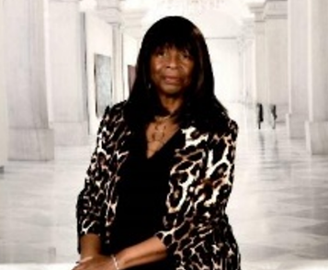
Gloria Stanley-Dews retired from AT&T after 40+ years. She continues to work as a part-time Travel Consultant and works with the UCSF PFAC (Patient & Family Advisory Council) as a focus group member. She heads the Bayview Community Outreach Ministry, which includes seven churches and 25 members and continues to grow. She helps to distribute fresh produce twice a month, and the Ministry gives out hot meals once a month. The Outreach Ministry and fresh produce programs support the neighborhood, seniors and the sick, and shut-ins, as they continue to reach out and connect with the neighborhood. She also continues to serve as a universal usher at various churches, as needed.

