**WAITING ON GOD**

Isaiah 40:31

Some life circumstances leave you searching around for answers or for someone to help. But these are opportunities to learn to wait on God to show the right way.

Waiting on God demonstrates confidence and expectation. The Hebrew word for “wait” can also be translated as “hope.” To hope in God is to wait for His timing and His action. As we wait, God will give us a peace that helps us to be still and trust that He will work the situation out for our benefit. God will strengthen us to face each day, even when we don’t feel we can make it. (Isaiah 40:31.)

While waiting on God, we may experience paralyzing fear that leaves us unable to function. But the Holy Spirit will come to our rescue with the word of God. The Spirit brings Words that strengthen and give us new life when we are just existing without hope or direction. As our strength increases, we gain more trust in being totally dependent on the living God. We believe that while waiting, God is preparing us to receive His blessings.

But waiting on God is not a passive activity during which we do nothing. God wants us to be active in the work He desires to accomplish in our lives. He wants us to draw closer to Him. He wants our lives to point those who watch us to the gospel. As we wait quietly and trustingly, we honor God and encourage others to put their trust in Him.

I recall working with a woman who was having a difficult time on the job. I personally felt she was being treated unfairly. I watched how patient and loving she was when mistreated. Watching her caused me to want what she had. Her Christ-like attitude helped me become a believer.

What else can we do while waiting on God? While waiting on God, we can believe that He will hear our cries. (Micah 7:7.) We can put our faith in God’s word. (Psalm 130:5-6.) We can avoid trusting in our understanding of things and seek God’s wisdom. (Proverbs 3:5-6.) Finally, we can pray continuously and be thankful for all things. (1 Thessalonians 5:17-18.)

Waiting while remaining faithful and prayerful will build trust that God will work all things out for our good. When we learn how to wait with expectation and joy, God blesses us with wisdom and clarity, and His voice guides us. While we wait, God provides opportunities to grow in grace and the knowledge of Himself. The most rewarding blessing in waiting on God is that it proves we believe Him.

I’m still waiting on God to answer some of my prayers. I’m daily seeking God for my family, myself, healings for loved ones, and healing for this country. While waiting, I continue praying and believing that God’s perfect will, will be done.

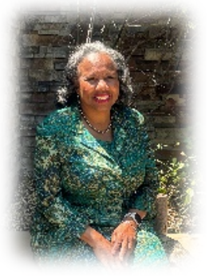

*Sister Jackie Manion is a mother of four, grandmother of five, and great-grandmother of four. She is the Executive Director of Our Kids First Educational Program, a non-profit after-school program. Sister Jackie studies with the DOZ Women’s Ministries, where she serves as an Intercessor. She was an active San Francisco Christian Center member for 32 years. Jackie currently attends the New Beginning Christian Community in Redwood City. She loves God, His People, and His Word.*