BLESSED AND GRATEFUL

God has performed many miracles in my life. My son, Le’Otis, was in a life-threatening car accident in July of 2017. When I received the call, I called on JESUS. Calling His name was all I could do. There is power in the name of JESUS. At the hospital we were placed in a conference room, and the State Trooper responding to the accident came in and prayed with us. He told us, “Everything is going to be alright.” The doctor came in afterwards and said my son’s condition didn’t look good. The doctor started telling me how serious the injuries were and about the surgeries that would be needed, but I interrupted him and said, “The battle belongs to the LORD, and it’s already WON.” My son had a traumatic head injury. His brain was swollen and bleeding. The doctor anticipated a long hospital stay.

The day I waited for them to take Le’Otis to surgery, I witnessed the presence of the Lord in his room. The lights were dim but suddenly the room lit up extremely bright. The nurse asked, “Wow! Did you see that?” I responded, “That’s JESUS.” On another occasion, I sat reading scriptures to Le’Otis when an enormous roar of thunder shook the room. Outside his window a face appeared in the sky, and my daughter said, “Mama you’ve got to see this.” I observed the face and told my daughter, “That’s JESUS.” The thunder roared and His face shined upon us. I received these signs as GOD’S ASSURANCE that everything was going to be fine. HE stepped in to perform a miracle on HIS child.

After the surgery, Le’Otis could hear my voice but could not see me. The accident left him with blindness in his left eye, low vision in his right eye, nine metal plates held by 52 screw in his forehead, and a broken right ankle. I told Le`Otis, “This is only a test we must pass.” Within one month and a day, my son was walking and released from the hospital.

God HEALED and BLESSED Le`Otis to return to college and graduate with honors in 2019. YES, I’m so grateful God allowed me to witness this MIRACLE.

After Le’Otis’ accident I thought life’s storms were over – I was wrong. In January of 2019, my daughter fell ill and couldn’t ingest food. She had been misdiagnosed multiple times. I decided to take her to the University of Alabama Hospital in Birmingham. They discovered that she had a leaking appendix infecting her entire body, and her kidneys were malfunctioning. The doctor said we had arrived just in time to save her life. She was treated with heavy doses of antibiotics and drainage tubes. She was really depressed. I told her, “TRUST JESUS, because He’s a healer, and I know He’ll heal your body.” After a week and a few days, she was released and resumed her normal routine.

On April 6, 2020, God blessed me to survive a massive heart attack. Our GOD is AWSOME!

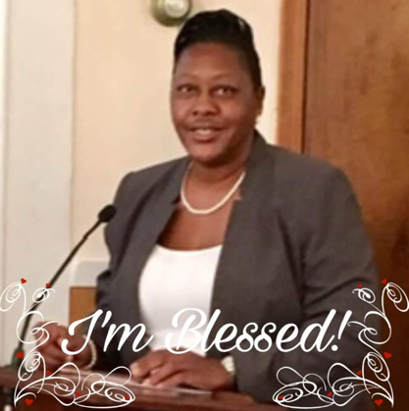
Verna R. Nickson is a native of Eutaw, Alabama. She is the blessed mother of a daughter and a son, and the blessed grandmother of a grandson. Verna is a member of Zion Brush Creek Missionary Baptist Church. She retired from Greene County Board of Education as a School Bus Driver after 29 years of service. Currently, she joyfully works with the Elderly Assistance Program in Eutaw and enjoys spending time with her children, traveling and cooking.

