Trust God
Trust - to rely upon or place confidence in someone or something

Happy New Year Saints! Wow 2020 – who would have ever thought . . . ? Being a 60’s baby it seemed so far away, but here it is. The new year brings hope and uncertainty. As we see the world leaning more toward evil and deception, I encourage you to trust God.

Believers know how important it is to trust God with everything. We trust not only that He is who He Is; we also trust that He is every single thing that we need. We know that 2020 will bring even more changes and instability to our lives, but “those who trust in the Lord are like Mount Zion, which cannot be shaken but endures forever.” (Psalm 125:1.) He is the same yesterday, today and forever; completely reliable and able to keep us steady.

In the Message Bible Proverbs 3:5 says, “Trust God from the bottom of your heart; don’t try to figure out everything on your own.” The Amplified version reads, “Trust in and rely confidently on the Lord with all your heart and do not rely on your own insight or understanding.” The call is to put our lives in God’s hands and leave everything to Him. Simply believing in God is not enough, because He wants us to give Him our lives.

Many of us start off the new year with resolutions, because there’s something we want to change. Maybe decisions made in the past didn’t pan out, or perhaps we just want to try something new. We abandon our resolutions no sooner than we start them, because things constantly change. The secret to successfully navigating life is to trust in God, because He never changes. If we want consistency, we have to acknowledge God in everything, and trust that He will direct our paths.

God wants us to live life and live it more abundantly. Jeremiah 29:11 says, “For I know the plans I have for you, declares the Lord, plans to prosper you and not to harm you, plans to give you hope and a future.” (NIV)

As long as God, who knows the future, provides the agenda and goes with us as we fulfill His mission, we can have boundless hope. So immerse yourself in the Word of God, and learn what pleases Him. Trust that He will lead and guide you through this journey called “Life”. “Commit thy way unto the Lord; trust also in Him, and He shall bring it to pass!” (Psalm 37:5).

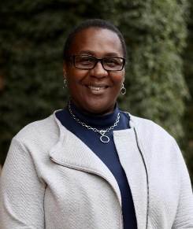
Sheila is a wife, a mother, and a native of San Francisco. She is a member of the San Francisco Christian Center where she serves as a greeter. Sheila also studies with the Daughters of Zion because she loves studying the word of God.

