Faith Moves Mountains and Forgiveness Fuels Faith

You can often tell what is important to a person by paying attention to their words just before they leave you or just before they die. Now in September a lot of parents are giving parting words of advice to kids heading off to college. Parents want to get more important lessons across before the kids are too far away to talk to all the time. I can remember reminding my kids to be sure to go to church on Sundays, to seek out Christian friends, spend their money wisely and to do their best in everything they put their hand to.
In Mark chapter 11, we see Jesus heading to the cross. Even though his disciples are having a hard time accepting it, Jesus is letting them know that his days are numbered and that he will suffer. He is also taking the time to share some last lessons and to say some final important words to his disciples. He knows these words will be powerful and remembered. In Mark 11:22 he tells them, “have faith in God,” and he lets them know that their faith is powerful enough to move mountains into the ocean. That’s an awesome thing. I imagine Peter and John had Jesus’ words in mind when they healed the crippled man at the temple gate as told in the books of Acts.
Jesus also reminds his disciples of the importance of forgiveness. He tells them that they can do great things. But, great things come at a big price and that price is forgiveness. He tells them in verse 25, “When you stand praying, if you hold anything against anyone, forgive them.” Jesus knew the disciples were going to face hard times and were going to need to forgive often.
Forgiveness is something I work at constantly. I have to choose daily to not focus on hurt, and to forgive a harsh word or thoughtless act. Not forgiving becomes burdensome to me. I become aware of the fact that I am not forgiving others when I find it hard to forgive myself. Jesus tells us we need to forgive others so that he can forgive us. When I am not forgiving others, I acutely feel the lack of heavenly forgiveness in my own life.
I need to forgive if I want to move mountains. I want to move mountains, because clearing the path is sometimes better than leaving an obstacle in the way. So, forgiveness must become a daily practice for me. When I look back on my life and consider the mountains that God has moved for me, it serves as a reminder of the forgiveness that needs to continue in my life.

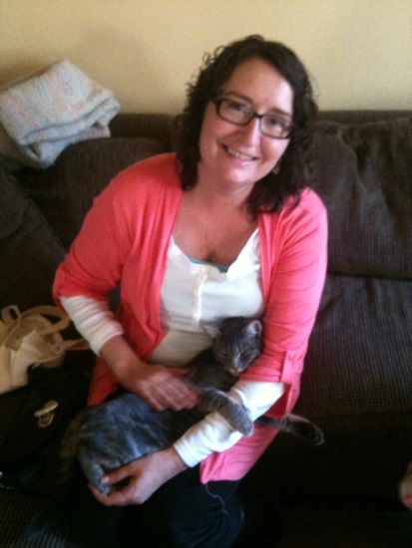 Brenda Boston has been a Daughter of Zion for five years. She is a former missionary/church planter to the countries of Peru and Paraguay. She lived in these countries for 20 years before God brought her back to San Francisco. Brenda and her husband Rev. Robert Boston are planting a church in the Mission District of San Francisco. Brenda works full time as an RN and beside her husband in the church.

