The Choice is Yours
Deuteronomy 30:15

Charles Dickens, the author of, A Tale of Two Cities, wrote:

It was the best of times, it was the worst of times, it was the age of wisdom, it was the age of foolishness, it was the epoch of belief, it was the epoch of incredulity, it was the season of Light, it was the season of Darkness . . . .

In short, he describes a time filled with contradictions. We also live in an awkward and tumultuous season, where God’s light and love stand in contrast to the fear and darkness, lawlessness, and violence that run rampant in our world. The absurdity, blindness, and rebellion of men are unlike we have ever seen in our history. For many it is the worse of times!

Some have lost jobs, loved ones, homes, and even their minds. Others have lost their sense of direction, security, peace, and joy. Strife, anger, and bitterness inflame the hearts and minds of men causing them to lash out on social media, in their homes, on their jobs, in grocery stores, and in the streets. COVID-19, social distancing, politics and religious rhetoric have taken its toll producing a hostile and stressful atmosphere. Sadly, division and destruction have even invaded the body of Christ and personal relationships.

The enemy’s work is evident everywhere as the level of warfare increases. Yet, it is also the season of discovery, hope, change, and light. We are living in the most significant moments in history. The season of our God is upon us, and the work of the Holy Spirit is evident worldwide. There is a powerful shaking and awakening bringing revival, correction, and direction to the body of Christ.

We must not allow the current adversities to convince us this is our new normal, or that God’s promises will never come to pass. We must believe that just as the worst of time are upon us so are the best of times. Indeed, we are in a time of restoration. Doors are opening for us to walk through. Our health, businesses and finances are recovering. Ministries are coming forth in power.

During the worst of times we can certainly experience the best of times in Christ. God is restoring visual acuity; He is quickening our spirits to discern; and He is causing all things to work for our good. He is supplying and downloading divine strategies that will put the enemy to flight in our lives.

But to live in the fullness of all that God is getting ready to give us, we must choose between life and death, and good and evil. That means we choose to stop listening to idle chatter and salacious conversations. We will not entertain negative energy, bad attitudes, and ungodly behaviors. Instead, we will shut down and go into prayer so that we can hear and align ourselves with what God is speaking to our spirits. His words are spirit, and they are life.

Deuteronomy 30:15, says, “See, I have set before thee this day life and good, and death and evil.” What will you choose?
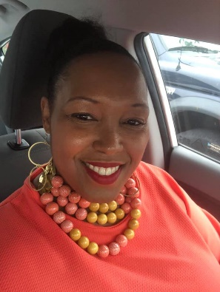 Minister Kasiaa Thomas is a born-again believer and native of San Francisco. In October of 2005, she was licensed to preach and mentored by Dr. Steven A. Bailey, of the Olivet Missionary Baptist Church in San Francisco. She served faithfully for years under his leadership as an Associate Minister, Junior Women's President and Prayer Ministry Leader. Minister Kasiaa is a prophetic minister, teacher, singer, writer, entrepreneur, licensed Insurance Agent, and jewelry designer. She is employed by United Insurance Company of America in Richmond, California.
In 2013, Minister Kasiaa graduated from Patten University with an Associate Degree. One of her favorite scriptures is 2 Timothy 2:15. She believes in accurately teaching and preaching the word of God. Her greatest joy is seeing people restored to life.

