IT IS FINISHED

When he had received the drink, Jesus said, “It is finished.” With that, he bowed his head and gave up his spirit. John 19:30

Finished! ! ! It is a word that celebrates the end of a task that is completely done. The phase, “It is finished” is a saying that can be taken out of context and be applied to different personal situations. The true celebration in these words comes with knowing that Jesus gave us victory over sin through his finished work on the cross.

My Sister was on the phone sobbing to her friend and telling her all the negative things that were going on in her life. I stood by quietly screaming inside, “Shut-up! Don’t tell her what is going on with you.” My sister could not discern the craftiness of this person, because she was someone in whom my sister had great trust and confidence. However, even as a new Christian I could discern that her friend was a wolf in sheep’s clothing. She was the type of deceptive person Jesus mentioned in Matthew 7:15. I could only pray that this friendship would come to an end. I wanted my sister safe and the association to be completed and finished.

We all experience trauma in the form of deception, pain, addictions to people, food, or drugs, depression, or sickness of our own or a loved one. But there is hope in Jesus to overcome every attack the enemy launches. Our trials develop strong faith and confidence for living victoriously every day. One sure way to live victoriously is to live a life of purpose and determination. If Jesus did not have a purpose in life, His words, “It is Finished,” would have no meaning. He stayed on task until the work of salvation was completed.

Just like Jesus, we should live a disciplined life. Discipline empowers us to say, “No!” when necessary without reservation or intimidation. Also, having discipline to be obedient to God and what He commands, despite opposition, guarantees that Jesus will fight for us. God even tells us that the battle is not ours but the Lord’s. (2 Chronicles 20:15.) Another way stay on task for the Lord is to willingly suffer for Christ. Through suffering we can say, “I am crucified with Christ: nevertheless I live; yet not I, but Christ liveth in me: and the life which I now live in the flesh I live by the faith of the Son of God, who loved me, and gave himself for me.” (Galatians 2:20.)

Jesus has already won the victory and through Him we too are conquerors. In Christ IT IS FINISHED! ! ! Amen!

Maviyah Bailey- Lewis

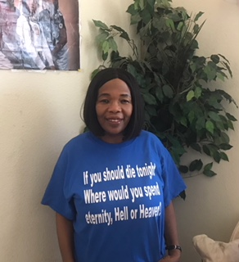
Maviyah retired from City College of San Francisco, Human Resources Department two years ago. She has been a member of the DOZWM for approximately 20 years, and she is a member of Word of Faith Church in San Pablo, California. Maviyah serves as an Altar Worker, Apollo's Ministry Assistant, and heads the Extreme Evangelism Ministry at Word of Faith with her sister, Claudine. She is married and lives in Oakland with her husband and two dogs.

