COVERED
2 Corinthians 1:3-11, Psalm 91

Everything we go through has a purpose – even the hard and difficult times. We have assurance that God has intentionally arranged every event to achieve His will for us. With this in mind, we should thank God! Yes, thank Him! Thank Him because He is our covering and our shield during hard times. Thank Him because He is the source of all comfort! Thank Him because He is our joy and our hope when the way looks dark. Thank Him because He provides everything we need for the journey. Thank Him because He is pulling out purpose that He placed in us before we were born.

Along the journey God comforts us, so we can comfort others and teach them what we have learned while we are still going through. He shows us compassion, love, mercy, grace, and so much more. Believe it or not, what helps us on our journeys helps others as they watch us go through our own processes of pain and healing. So, count it all joy because of His covering, and also because we can help others through our testimonies.

We need not fear defeat, because we are never alone on our journeys. God is with us and has placed our very own angel as a guard over us. When we need help God encourages us to come boldly to His throne of grace that we may obtain all that we need for this journey and the next. We can go to God’s throne often during difficult times to remain stable in our faith no matter what comes our way. God gives us peace during troubled times, and He will calm every raging sea. He can bind up the broken-hearted, He heals the most painful wounds, and He brings hope and joy under the heaviest sorrows. Because of everything God does for us, we have a duty to help others. We can offer prayer or a helping hand to help those going through pain and suffering, or rejoice with others during times of praise and thanksgiving.

Psalm 91 is one of many good passages that we can pray over ourselves while going through life struggles. This scripture has helped me many times. The message gets my mind and heart in the right place and helps me focus on the right things; such as God’s love, His righteousness, His promises, His hope, and many more positives. When my faith gets stronger and begins to grows, I become stronger in my stand against negativity and the enemy. Scripture reminds us of God’s protective covering over our lives. Knowing that we are covered enables us to stand boldly in our positions and know that everything is alright.

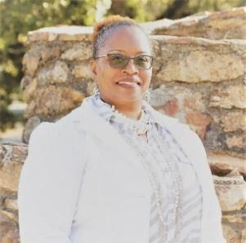
Helen Gill-Smith is a mother, grandmother, retired city government employee, singer, song arranger, music director, teacher, actress, motivational speaker, writer, and founder of "Dare to Heal Experience" Ministries. She holds a Bachelor of Arts Degree in Management and has helped countless ministries and businesses expand by contributing her organizational and creative skills. She is a member of DOZ and a member of New Destiney Church. She is also an Ambassador of the Freedom from Trauma International Group where she is now in an expanded leadership role.

