DESTINY IN THE DESERT

Now an angel of the Lord said to Philip, “Go south to the road—the desert road—that goes down from Jerusalem to Gaza.” Acts 8:26

I have a list of places I would rather not go and things I would rather not do. They say nothing compares to the thrill of climbing to the top of Mount Everest. I’ll pass. People around the world eat insects, and in parts of China earthworms are a delicacy. Please don’t put any on my plate. Wearing a mask recently made the list things I would rather not do. The elastic irritates my ears, my glasses fog up, and the cloth over my nose is sweaty and hot. It’s something I endure as a form of mild torture.

The entire COVID-19 pandemic is something I would rather not do. Bare grocery store shelves and long lines at Costco seemed like signs that the world was heading into a famine – maybe it was just a toilet paper famine but a famine, nevertheless. Added to this, family and friends had to isolate themselves, and I felt a little depressed not interacting with people outside of my household. The pandemic has the look and feel of a wilderness experience to me.

The Bible has many references to wildernesses and deserts. Deserts are often places for reflecting on our relationship with God. In the Old Testament the Israelites wandered in the desert for 40 years while reflecting on their sins and how they had rejected God. Still, God guided, cared for, and fed them throughout this punishment. After their sinful ways – and sinful people – died in the desert, the Israelites moved on to the promised land. (Numbers 32:13.)

Immediately after his baptism Jesus went into the desert to fast and pray for 40 days. Jesus was vulnerable, alone and without food or water when the devil tempted him. But this desert experience lead to the greatest victory of the Spirit over the flesh in history. After rejecting temptation, the desert became a place for renewal, as angels came to minister to Jesus there. (Matthew 3:13–4:11.)

The deserts in our lives are always disturbing places filled with uncertainty, fear, and doubt, but they can bring significant spiritual renewal. Few people would willingly go into the desert, but God still uses desert experiences to help us reflect and renew. In Acts chapter 8, God sent Philip into the desert to minister to an Ethiopian eunuch. This likely was not a pleasant experience for Philip. The desert between Gaza and Jerusalem is hot, dusty, and windy. But Philip endured the elements to share the gospel and further expand God’s kingdom on earth. Philip’s destiny and that of the eunuch joined in that divine appointment in the desert.

I am certain that my destiny, and that of all believers in Christ, is on a divine course going through this pandemic desert. I pray that we find renewed faith in the fear, loneliness, and uncertainty.

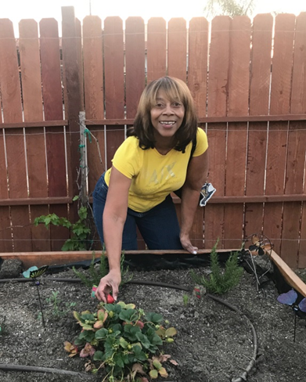JANIE WHITE is a member of Star of Hope Missionary Baptist Church in San Francisco, California where Rev. Gordon Thomas is Pastor. She enjoys Bible Study, and in addition to studying with her congregation, she is a member of the Daughters of Zion Women’s Bible Study organized by the founder and teacher, Minister Shirley Freeman. Janie is passionate about the Word and discipleship—especially helping others by demonstrating the love of Christ through service.

