Be a Life Giver

In every encounter, we either give life or we drain it, there is no neutral exchange.
Brennan Manning

For consecration this year I gave up the news. It wasn’t a hard decision to make, since I have so much going on in my life that I really don’t have the energy to try solving the world’s problems anymore. I’ve also been increasingly concerned about the polarizing aspect of what we hear on the news these days. I just don’t feel good anymore when I listen to the news. I feel a churning in my gut and a restlessness in my spirit.

Most importantly though, I don’t want to listen to anything that is going to drain life from those around me. I feel like I need to listen to and read things that feed my soul and edify my spirit so that I can give life to those I have contact with on a day-to-day basis.

So I spent the 40 days of consecration listening to Christian music in those moments where I previously listened to the news. I found myself repeating the lyrics over and over in my head all day long. God is good, He is my Father, All My Hope is in Jesus, I don’t want to gain the whole world and lose my soul. Those lyrics circulated in my head all day long.

With the eye of my soul in the right place, and with words of the Spirit on my tongue, I found I had words of hope for others. This turned out to be a greater blessing than I anticipated. Words of encouragement filtered up from my heart and into my head. When there were no encouraging words, I was able to keep silent. I even found the strength to hold my tongue and answer wisely in difficult conversations.

The Bible does not tell us that we have to speak our mind or that we should walk away from every conversation confident that our point was made. It does tell us over and over to guard our tongues, have prudent lips, promote peace and be kind. Feeding my soul with spiritually enriching words gave me more control over my tongue. I may not have complete mastery, but those are the things I am working on these days.

The words of the reckless pierce like swords,
but the tongue of the wise brings healing.
Proverbs 12:18

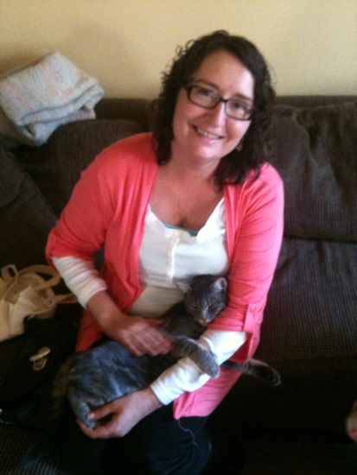

Brenda Boston has been a Daughter of Zion for five years. She is a former missionary/church planter to the countries of Peru and Paraguay. She lived in these countries for 20 years before God brought her back to San Francisco. Brenda and her husband Rev. Robert Boston are planting a church in the Mission District of San Francisco. Brenda works full time as an RN and beside her husband in the church.

